**INTRODUCTION**

College Notes Gallery is a web based notes sharing and management system which helps students and teachers to share their notes online effectively. It reduces the wasting of time in manually distributing notes to each individual. It greatly overcomes the lack of availability and converts the manual old school paperwork to a fully automated and managed online system.

College Notes Gallery allows it's users to securely register and log in to their individual accounts and create, read , update, delete notes according to their needs. It provides notes to everyone in a very secure manner. Multiple users can work in this system at the same time under centralized supervision by administrator. It is a very useful notes management system for Colleges, Schools and other Institutes to manage and share their notes in an secure, efficient and effective manner.

**OBJECTIVE**

The objectives of the system are-

* To reduce manual paperwork.
* Reduced sharing and distribution time.
* Increased reliability.
* Increased operational efficiency.
* Data security**.**

This Notes Management System can be readily used by non-programming personal avoiding human handled chance of error. This project is used by Three types of users

* 1. Students.
  2. Teachers
  3. Administrators

Students and Teachers can create their accounts and start viewing notes shared by other users as well as upload their own notes.

Administrator is must be an authorized user who will keep track of all the uploaded notes and manage users as well through the admin panel.

New features can be added to the system as per requirements.

**MODIFICATION AND IMPROVEMENT OVER THE EXISTING IMPLEMENTATION**

**Present State:**

* No Software present at all.
* Time consumed in distributing notes to everyone individually.
* Manual Paperwork.
* Students are informed by sending mail to them manually about the notes.
* Lack of accessibility.

## After implementation of project:

* Easy to use web based system.
* Users can register online.
* Notes are accessible from anywhere.
* Centralized control by administrator.
* Managed notes in a secure manner.

## SCOPE

This project has a large scope as it has the following features which help in making it easy to use, understand and modify it:

* Ease of sharing notes
* No Need to do Paper Work.
* To save the environment by using paper free work.
* To increase the efficiency of the notes.
* Management of all notes.
* Easy and secure user log in and registration.
* Easy password recovery through email.
* Department based notes management.

**Main Points are:-**

* Simplified Management of all notes.
* Upload of notes.
* Approve and disapprove notes features.
* Admin Panel.
* User profile management.

## TOOLS AND TECHNOLOGY USED

**Tools**:

**X AMPP:** XAMPP is free open source software that provides an easy way for web

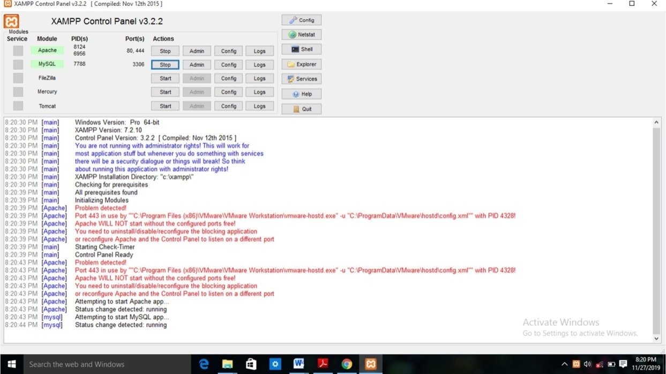designers and developers to install the necessary components to run PHP based software like Word Press, Drupal, Joomla, and others on Windows, Mac OS X, and Linux.

Fig : XAMPP control panel

* **PhpMyAdmin** :- **phpMyAdmin** is a free and open source administration tool for MYSQL and [MariaDB.](https://en.wikipedia.org/wiki/MariaDB) As a portable [web application](https://en.wikipedia.org/wiki/Web_application)written primarily in [PHP,](https://en.wikipedia.org/wiki/PHP) it has become one of the most popular MySQL administration tools, especially for [web hosting services](https://en.wikipedia.org/wiki/Web_hosting_service).

**Technology:**

* **PHP** : - PHP (recursive acronym for *PHP: Hypertext Preprocessor*) is a widely-used open source general-purpose scripting language that is especially suited for web development and can be embedded into HTML.
* **SQL**: - SQL is a structured query language used for querying database.
* **HTML**: - It is used for giving eye catching look to the website. And also providing easy to use GUI.
* **CSS**: - CSS is cascading style sheet which is used to give designer look to HTML using the external file.
* **Java script**: - Java script is used for client side scripting which can help in using validation on the website and many more other functions.

## TIME FRAME REQUIRED FOR VARIOUS STAGES OF PROJECT IMPLEMENTATION

|  |  |  |
| --- | --- | --- |
| Sr.  No. | PHASES | TIME DURATION |
| 1. | Software Requirement Specification | 1 weeks |
| 2. | System Design | 1 weeks |
| 3. | Coding | 4 weeks |
| 4. | Implementation | 2 weeks |
| 5. | Testing | 3 week |

**REFERENCES**

* <http://php.net/>
* [www.stackoverflow.com](http://www.stackoverflow.com/)
* <https://www.mysql.com/>
* https://github.com